ELECTRICAL POWER SYSTEM FOR A 1U NANOSATELLITE

EPS – Electrical power subsystem

OBC – Onboard computer

MCU – microcontroller unit

RPi – Raspberry pi

LDO – Low Dropout Regulator

SoC – State of Charge

# **INTRODUCTION**

The Electrical Power Subsystem (EPS) is a fundamental component of any satellite, responsible for generating, storing, regulating, distributing, and protecting electrical power throughout the spacecraft. In a resource-constrained platform like a 1U nanosatellite, the EPS must be carefully designed to ensure maximum energy efficiency, fault tolerance, and mission longevity.

The EPS collects energy from solar panels, stores it in onboard rechargeable batteries, and regulates it to the appropriate voltage levels required by different satellite subsystems. It then distributes power to components such as the onboard computer (OBC), communication module, telemetry system, and payload while ensuring protection against overvoltage, undervoltage, and electrical faults. Given the unpredictable and harsh space environment, the EPS also incorporates monitoring and control logic to optimize power usage and maintain mission-critical operations during low-energy periods (e.g., eclipse phases).

In CubeSats, especially in the 1U format (10 × 10 × 10 cm), size and mass limitations impose strict constraints on power generation and storage. A typical 1U nanosatellite may only generate 2 to 10 watts from its solar panels under optimal sun exposure. Therefore, power must be carefully budgeted and dynamically managed to ensure all essential systems remain functional throughout the mission.

The EPS in this design leverages a modular architecture, dividing its functions into several tightly integrated subsystems: power generation, storage, regulation, distribution, monitoring, and control/protection. Each of these subsystems contributes to the reliable and efficient operation of the satellite. Smart microcontroller-based logic using the MSP430 ensures that power is prioritized and regulated in real time, while the ESP32 and Raspberry Pi 4 operate in coordination for telemetry and payload processing.

Ultimately, the EPS serves as the heartbeat of the spacecraft, enabling all other systems to function effectively. A well-designed EPS not only extends the operational lifetime of the mission but also protects the satellite from irreversible failures.

# **SYSTEM REQUIREMENT**

The design of the Electrical Power Subsystem (EPS) for a 1U nanosatellite is driven by a combination of power consumption needs, orbital constraints, and form factor limitations. These requirements inform the sizing and configuration of solar panels, battery storage, regulators, and control logic.

## Power consumption needs

Power consumption estimation is the foundation of EPS design, as it determines the sizing of solar panels, battery capacity, and voltage regulation circuitry. In this 1U CubeSat design, power is consumed by the core electronic subsystems responsible for satellite operation, communication, telemetry, and control.

The satellite architecture features three main microcontrollers — the Raspberry Pi 4, ESP32, and MSP430 — each with different processing capabilities and power profiles. These MCUs are supported by sensors, communication modules, and other peripheral components, all contributing to the total power draw.

Table 1 Power consumption by various MCU

|  |  |  |  |  |  |  |
| --- | --- | --- | --- | --- | --- | --- |
| **Subsystem** | **Controller** | **Operating Voltage** | **Peak Current** | **Peak Power** | **Average Power** | **Operational Notes** |
| Onboard Computer (OBC) / Payload | Raspberry Pi 4 | 5V | 2.5 A | 12.5 W | 3–6 W | High usage during image processing or uplinks |
| Telemetry | ESP32 | 3.3V | 0.25 A | 0.83 W | 0.3–0.5 W | Transmits housekeeping and system data |
| EPS Control | MSP430 | 3.3V | 0.0005 A | 0.0016 W | <0.001 W | Always on; very low power watchdog role |
| Other Peripherals | Sensors, LEDs, etc. | 3.3–5V | ~0.1–0.2 A | ~0.5–1.0 W | ~0.3 W | Depends on mission payload and onboard sensors |

Total Peak Power is approximately 13.8 W while the typical operational power is 4.5–7.0 W

The Raspberry Pi 4 is the dominant power consumer, and will only be powered during critical tasks such as payload operations, image processing, or data uplink/downlink.

The ESP32 operates semi-continuously, especially for telemetry and simple command/control tasks.

The MSP430 is always on, performing real-time EPS supervision and acting as a watchdog or fallback controller.

Power cycling the RPi 4 and other subsystems intelligently is critical to conserving energy during eclipse or low battery conditions.

## Power availability

Although this project is a ground-based model of a 1U nanosatellite, the Electrical Power Subsystem (EPS) is designed to realistically simulate the energy constraints and logic of a space-ready system. Power availability is modeled based on realistic CubeSat design principles, using solar panels and a battery system to reflect how a satellite would manage power in orbit.

The model employs external solar panels or equivalent constant-voltage DC power supplies to simulate solar energy generation. In a real 1U satellite, solar panels are the primary source of energy, constrained by the small surface area and inconsistent sun exposure due to orbital dynamics.

In the prototype the simulated solar source provides ~4–6 W of usable power, equivalent to what a 1U CubeSat might receive from 2–3 high-efficiency panels under direct sunlight. This input serves as the charging source for the onboard battery, while also supplying power to live loads during "sunlit" operational periods.

**Simulation Element Equivalent in Orbit**

Bench power supply / PV panel Space-based solar panel

Controlled light source Orbital sun exposure

Manual light cycling Day/night (sunlight/eclipse) cycle

Although the EPS is not intended for actual deployment in space, it is developed using the same constraints and logic flow found in orbital CubeSat missions. This ensures that the model remains an effective testbed for real-world EPS strategies — including solar charging, energy management, fault response, and power distribution.

## Battery storage requirement

The battery subsystem in a satellite — even in a ground-based model — plays a central role in maintaining system stability and ensuring continuous operation during periods when energy input is unavailable or insufficient. In actual satellites, this includes eclipse phases; in this model, it simulates interrupted solar input, load peaks, or test scenarios where solar panels are deliberately disconnected.

The battery provides:

* Backup power when simulated solar panels are off (e.g., during eclipse simulation)
* Support for high-load phases, such as when the Raspberry Pi 4 is active
* Stabilized voltage rails for sensitive components (e.g., MSP430, ESP32)
* Energy storage during surplus solar generation

For this model, a 2S Lithium-ion battery pack is proposed, offering a nominal voltage of 7.4V (3.7V per cell), fully charged voltage of 8.4V and a discharged voltage threshold: ~6.0V–6.4V (with protection logic)

This configuration is ideal because it aligns well with standard buck converters for generating 5V and 3.3V outputs, provides a safe voltage range for most satellite-grade electronics and offers a buffer large enough to sustain low-power loads for extended periods.

In both real CubeSats and ground-based model, battery charging is done via the solar panels through a charging circuit. For a 2S battery configuration (7.4V Li-ion), the charging method must be safe, controlled, and efficient. The recommended charging method is use of a dedicated lithium battery charger IC that supports:

* 2-cell (2S) configuration
* CC-CV (Constant Current – Constant Voltage) charging profile
* Overvoltage and thermal protection
* Optional: MPPT (Maximum Power Point Tracking) for solar optimization

## Voltage regulation needs

The EPS must deliver stable, noise-free voltage rails to all onboard systems, regardless of variations in battery level or input from the simulated solar source. Each subsystem operates at a specific voltage range, and fluctuations — especially overvoltage or ripple — can cause performance degradation, misbehavior, or permanent damage.

The satellite model includes multiple components with differing voltage requirements, primarily the 5V for high-power devices like the Raspberry Pi 4 and the 3.3V for lower-power controllers like the ESP32 and MSP430

The main objective of voltage regulation is

1. Convert battery voltage (~6.4V to 8.4V) to regulated output levels
2. Protect sensitive electronics from overvoltage or ripple
3. Maintain high efficiency to minimize heat generation
4. Enable smart switching (e.g., shut off 5V rail during low battery)

The required voltage rails are 5V and the 3.3V which can be achieved by use of buck convertor or low dropdown voltage regulator (LDO)

# **EPS SUBSTEM DESIGN**

## Generation

The power generation subsystem is responsible for converting solar energy into usable electrical energy to charge the onboard battery and supply real-time loads. In this nanosatellite model, the goal is to demonstrate the principle of independent, renewable power generation, mirroring the behavior of space-grade solar panels in an orbiting CubeSat.

To achieve this, solar panels will be employed as the primary input source, supplying power to a battery charging circuit. The EPS logic and regulators then distribute this energy to downstream systems such as the OBC, telemetry module, and EPS controller.

For a ground-based prototype, the selected panels must:

* Output sufficient voltage to charge a 2S Li-ion battery (needs >8.4V)
* Have reasonable current output (100–500 mA)
* Be small enough to integrate with the 1U model enclosure
* Allow testing under indoor or outdoor light sources

**The recommended solar panel models are**

Table 2 Solar panel model recommendation

|  |  |  |  |  |
| --- | --- | --- | --- | --- |
| **Panel Model** | **Voltage / Current** | **Power** | **Dimensions** | **Notes** |
| **Adafruit 6V 3.5W Solar Panel** | 6V @ 580 mA | 3.5 W | 110 × 170 × 3 mm | High current, ideal for full 5V/3.3V demo load |
| **Voltaic Systems 6V 2W Panel** | 6V @ 330 mA | 2.0 W | 165 × 100 × 4 mm | Slim, fits on one CubeSat face (vertical) |
| **SparkFun Sunny Buddy Panel** | 6.5V @ 250 mA | 1.6 W | 110 × 70 × 3 mm | Compact, pairs well with MPPT chargers |
| **Generic 6V 1W Panel** | 6V @ 160 mA | 1.0 W | 110 × 60 × 2.5 mm | Small and modular, stack 2–3 panels |

Combining two 6V panels in parallel is the perfect design as it increases current while keeping Voltage constant.

The solar panels are connected to a charger which in turn charges the battery.

## Storage

The power storage subsystem is responsible for accumulating and storing electrical energy for use when solar input is insufficient, unavailable, or when subsystem demands exceed generation capacity. In both real CubeSats and ground-based models, this subsystem plays a crucial role in ensuring continuous, uninterrupted operation — especially during eclipse periods or peak power events.

In this nanosatellite model, energy harvested by solar panels is stored in a 2-cell (2S) Lithium-based battery pack, selected to match the system’s voltage and current requirements. The design utilizes a 2S (7.4V nominal) Li-ion battery pack, composed of two 3.7V cells in series. This configuration:

* Provides sufficient voltage headroom for regulation to 5V and 3.3V rails
* Is common in CubeSat designs
* Balances energy density with manageable charging complexity

For this model Li-ion is used due to its stability, safety, and standard form.

To prevent damage and ensure safety, the battery pack must be paired with a BMS circuit that handles:

* Overcharge protection (cutoff above 8.4V)
* Overdischarge protection (cutoff below ~6.0–6.4V)
* Overcurrent and short-circuit protection
* Balancing (optional for low-current applications)

In the prototype, a readily available 2S BMS board is integrated to handle this automatically, ensuring safe battery operation during all test cycles.

The EPS must also track battery voltage at all times to:

* Estimate state-of-charge (SoC)
* Trigger load shedding when voltage drops (e.g., shut down RPi at 6.8V)
* Enable or disable charging circuits

This is done using a voltage divider connected to an analog input on the MSP430 and/or ESP32, with software-defined thresholds for normal, low-power, and emergency modes.

## Regulation

The power regulation subsystem is responsible for converting the variable battery voltage (typically between 6.4 V and 8.4 V for a 2S pack) into stable, noise-free voltage rails required by the satellite’s microcontrollers and peripherals. These regulated outputs ensure each component receives the correct voltage level, protecting them from damage and ensuring reliable performance.

In this design, two main voltage rails are derived from the battery:

* 5V for the Raspberry Pi 4 and other potential USB devices
* 3.3V for the ESP32, MSP430, sensors, and control logic

Use of a buck converter for 5V to power the Raspberry Pi 4 and an LDO or low-current buck for the 3.3V line (ESP32, MSP430) were considered.

Some of the suggested ICs for regulation are;

|  |  |  |
| --- | --- | --- |
| **Function** | **Recommended ICs** | **Notes** |
| 5V Buck | MP2307, TPS5430, LM2596 | Supports up to 3 A, high efficiency |
| 3.3V LDO | AMS1117, MCP1700 | Simple, cost-effective for low power |
| 3.3V Buck | RT8059, AP63203 | Use if LDO heat is an issue |

To monitor rail health, voltage dividers are connected to MSP430 or ESP32 ADCs as well as enabling early shutdown of non-critical rails if voltage drops (e.g., battery <6.8 V)

## Distribution

The power distribution subsystem is responsible for routing regulated power from the 5V and 3.3V voltage rails to the appropriate components, while enabling the system to control, prioritize, and protect loads based on power availability, mission state, and fault conditions.

Two voltage rails are obtained i.e. 5V rail and 3.3V rail

# **COMPONENTS SELECTION**

From the design, the following components will be in use:

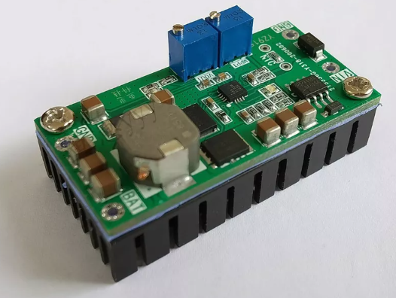

Figure 1 Solar Lithium Battery Charging Board MPPT Module With Heat Sink

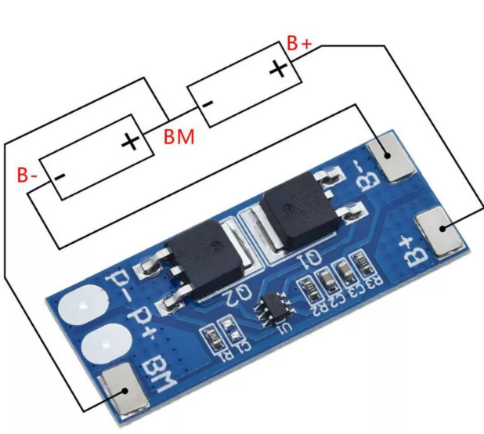

Figure 2 2S Li-ion Peak Current Battery Protection Board

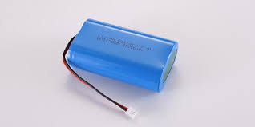

Figure 3 2S Li-ion batteries

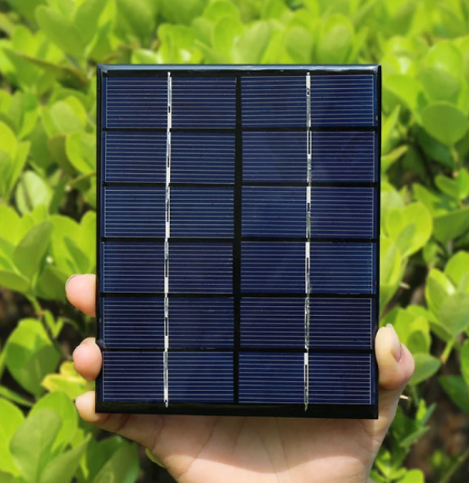

Figure 4 Solar Cell 6V 330mA

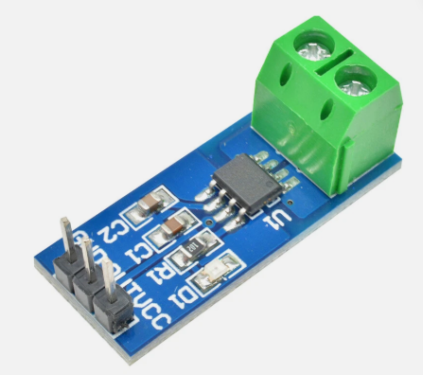

Figure 5 5A range Current Sensor

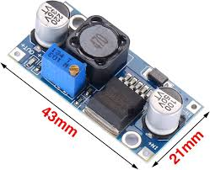

Figure 6 lm2596 DC buck convertor